**Aim**: Design Calculator using IF action

**Objectives**: To understand how to take user input and use if else conditions on it.

**Tools Used**: Automation Anywhere.

**Concept**: A calculator bot can be created in Automation Anywhere using the IF action to process user input and perform arithmetic operations based on conditions.

**Problem Statement**: To run a simple calculator bot which takes 2 numbers and 1 operator. By using the if else condition and return the expected outputs.

**Steps for creating a bot:**

Now create a new bot.

Add a prompt f to take or num1 input.

Convert num1 from string to integer.

Add a prompt to take num2 input.

Convert num2 from string to integer.

Add a prompt to take operator input.

Add if, else if, else condition on the operator

According to the condition perform calculation.

Convert the result from Integer to String.

Add a message box to show the Resultant value.

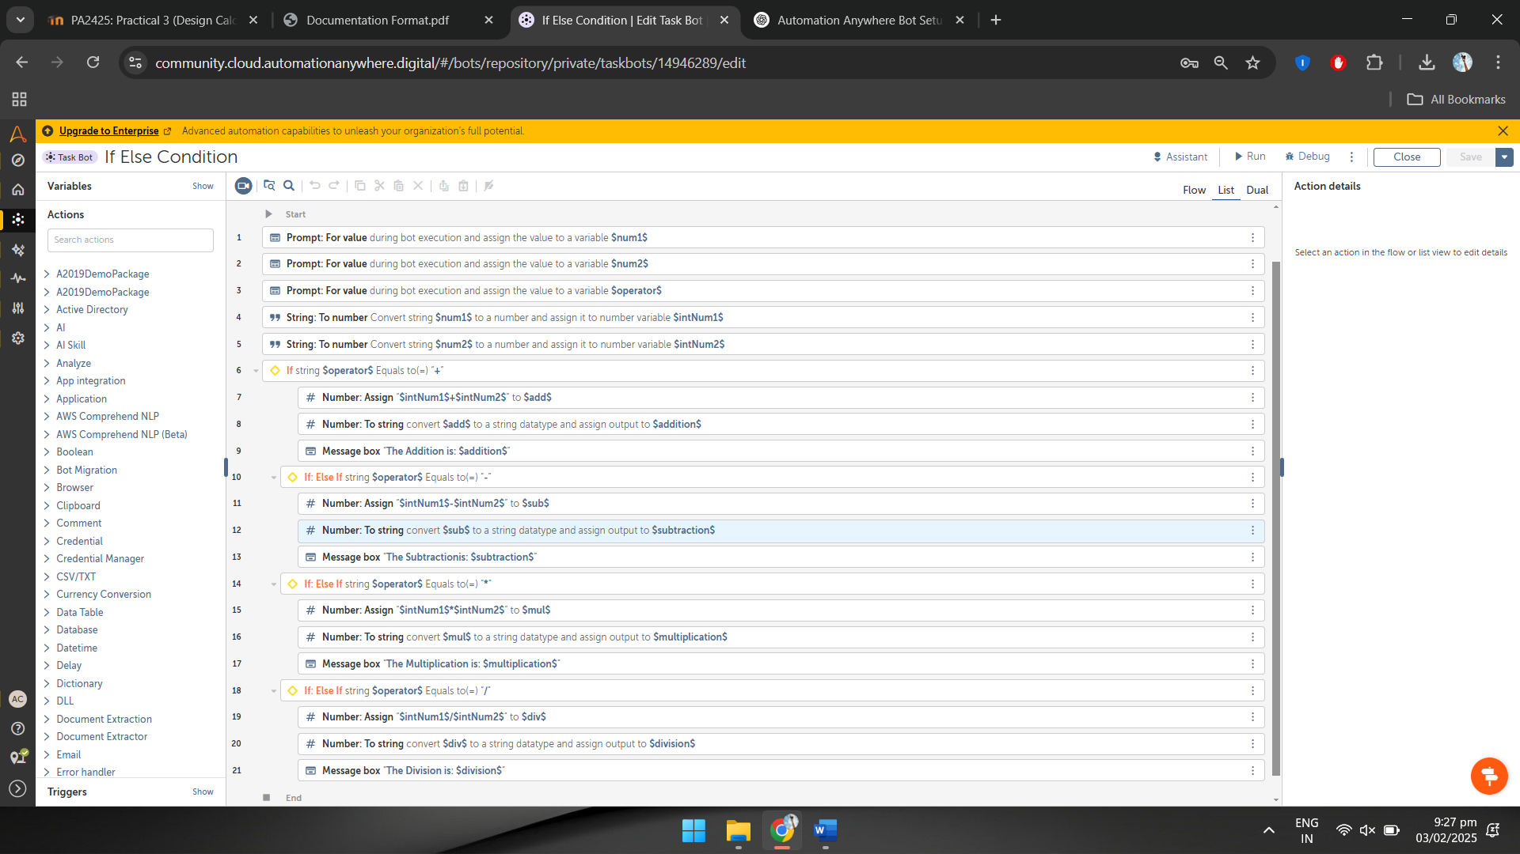

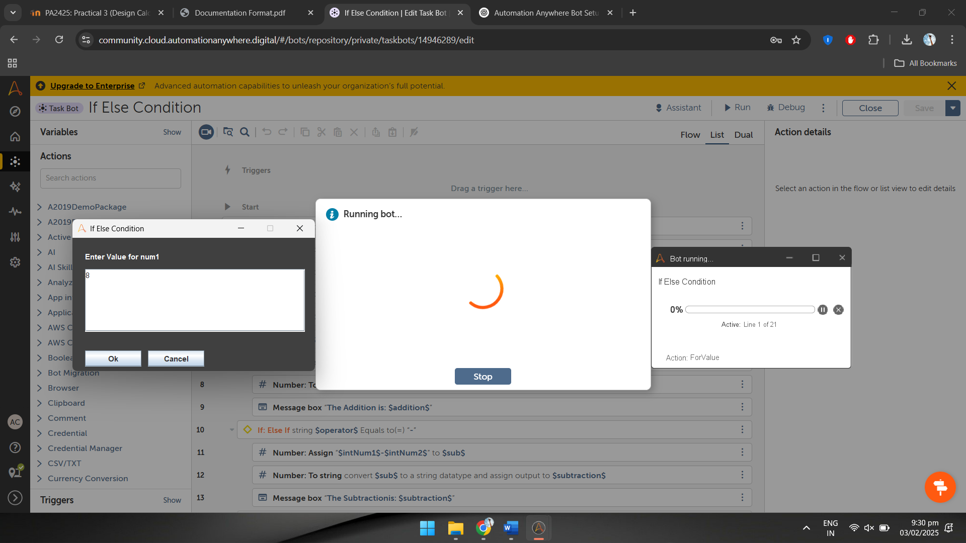

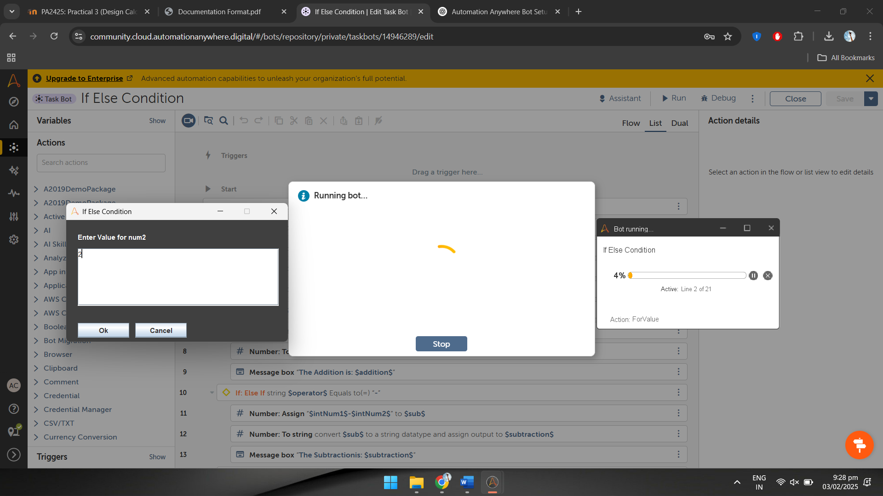

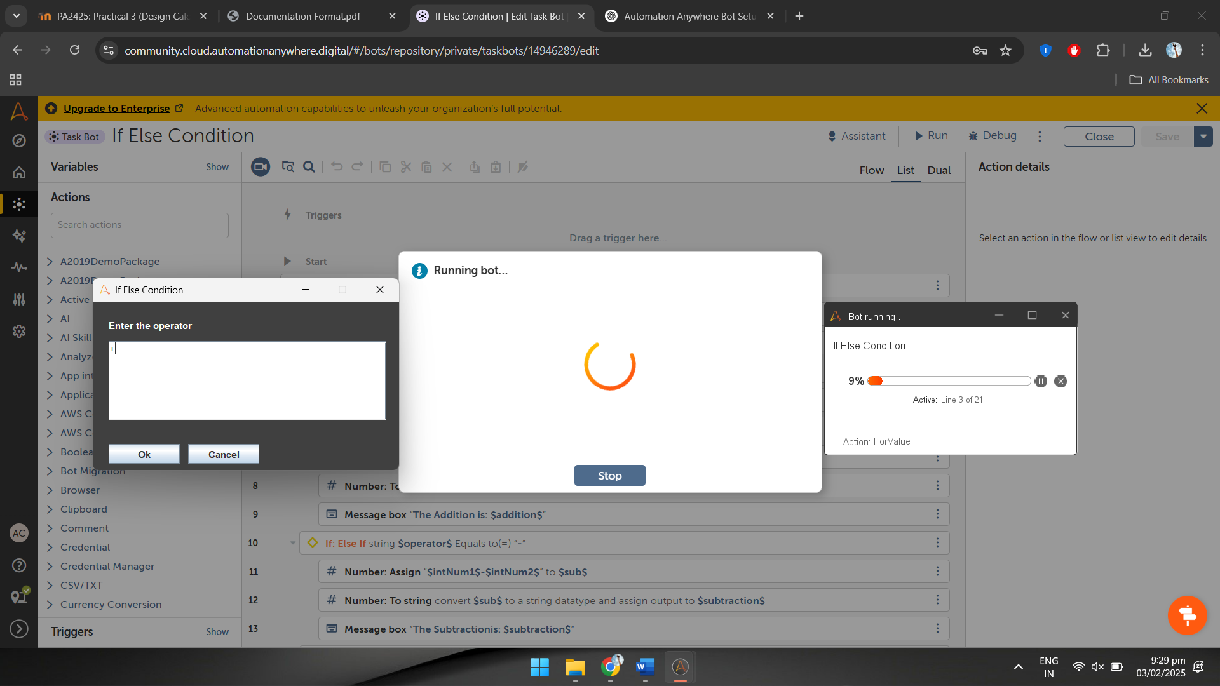

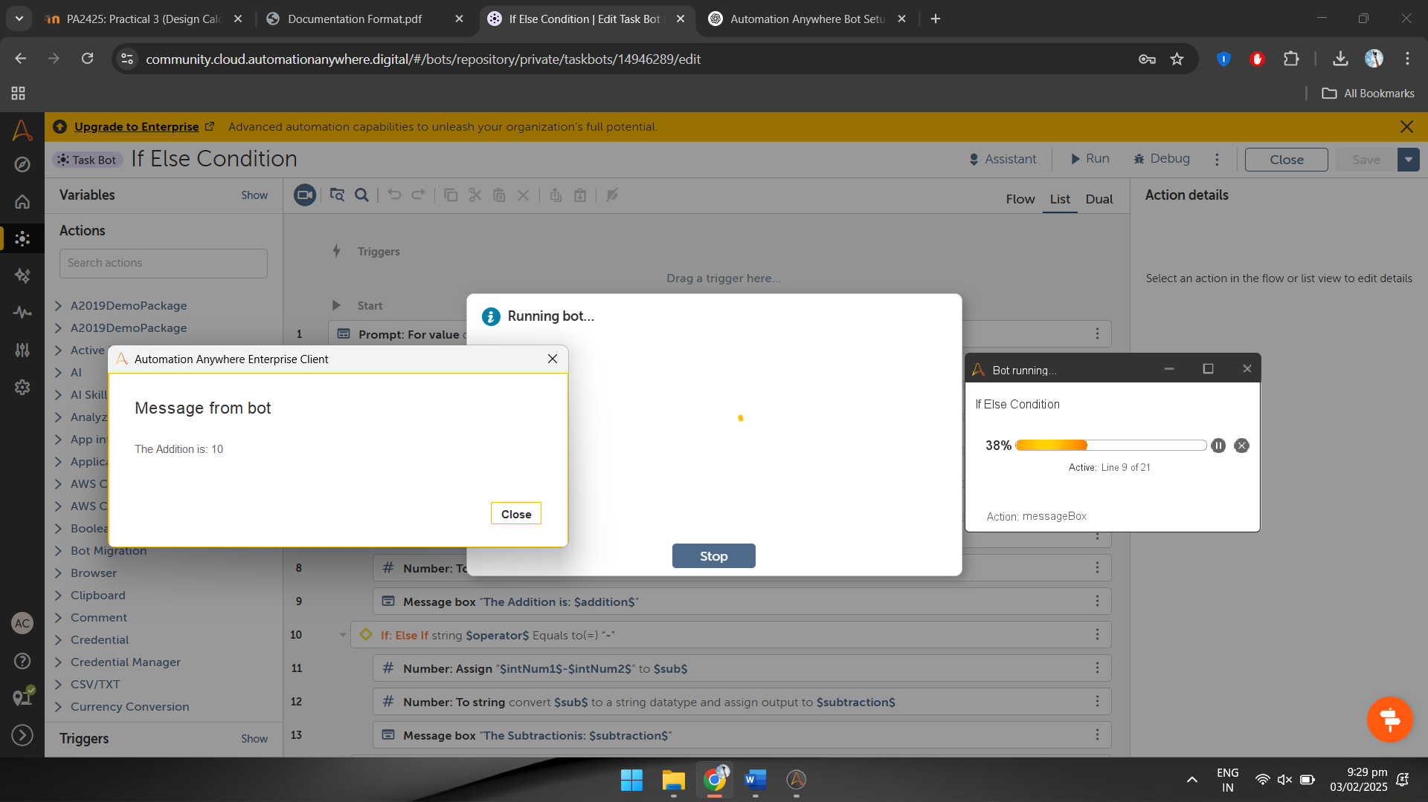

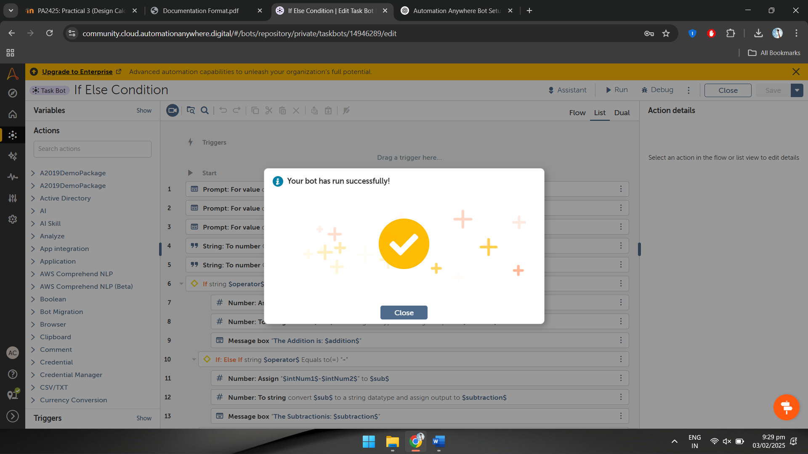

**Observation:**

The bot takes two numerical inputs and an operator as user input.

IF conditions are used to check the operator and perform the corresponding calculation.

The final result is displayed using a message box, ensuring correct execution based on user-provided inputs.